Curriculum vitae

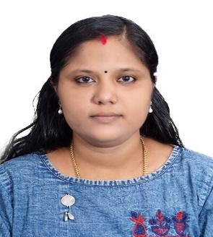
SARANYA.R.S
SARANYA BHAVAN (H)
MUDAKKAL(PO)
PIN: 695103
THIRUVANANTHAPURAM (DIS)
KERALA, INDIA
PH: 9497752550
Email:saranyasanthakuar007@gmail.com

Career Objectives

To obtain a challenging position in the teaching field that utilizes my education skills and experience forwards in the growth of the esteemed organization that can offer opportunities and challenges for professional growth and spirit.
Educational Qualification:_
- SSLC : Govt, of Kerala (99%)
- PLUS TWO : SCIENCE (84.33%)
- BSC Degree(PHYSICS) (86%)
- B.ED (PHYSICS) (81.27%)
Computer Knowledge:
- MS OUTLOOK
- MS WORD
Professional Strengths:
- Confident
- Communication Skill
- Friendly personality

Skill sets:
- Friendly nature
- Adaptable
- Fast learner
- Safety-oriented
- Hard working
- Honesty
- Self confident ,Punctual

Extra Activities:
- Reading book
- Traveling

Languages Known:
- English
- Hindi
- Malayalam

Personal Details:

Date of Birth : 21/FEB/1993
Marital Status : Married
Nationality : Indian
Religion : Hindu
Sex : Female

About Myself : Quick learner, Fast and careful, positive thinks, Result oriented, Dynamic and self – motivated

Declaration
I do hereby confirm that the information given by me as true to the best of my knowledge and belief.

Date:
Place: Attingal

