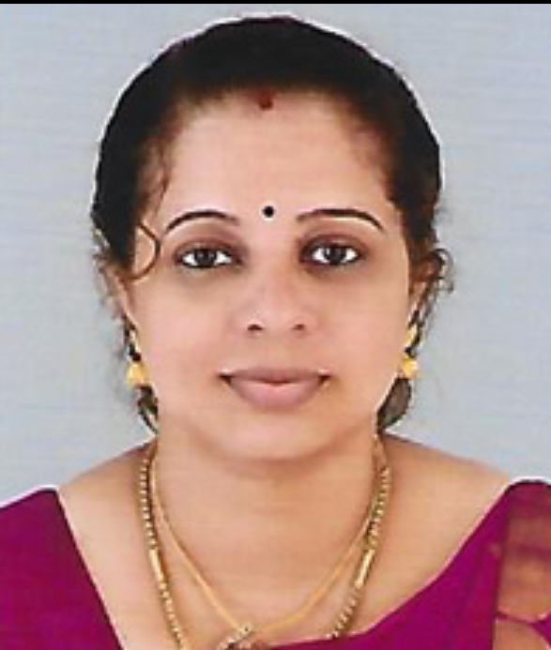 RESUME

Name : MONISHA T L E-mail : mt6088@gmail,com
Father’s Name : Y Thankamony Address : Shyla Nivas Idichakkaplamoodu
Mother’s Name : T Leela Parassala - 695502
Date of birth : 22nd May 1989 Thiruvananthapuram
Maritial Status : Married Kerala
Mob : 9496318217
Educational Qualifications :
Qualification | Institution | Year of passing | Percentage (%)
B.Ed Physical science | CSI College of Education Parassala | 2012 | 75.30
M.Sc Chemistry | NMCC Marthandam | 2011 | 70.97
B.Sc Chemistry | VTM NSS College Dhanuvachapuram | 2009 | 74.50
Plus Two | Evans HSS Parassala | 2006 | 66.67
SSLC | Govt VHSS Parassala | 2004 | 77.33

Additional Qualifications :
CTET (Central Teacher Eligibility Test) - Primary Stage
KTET ( Category II ) - For UP classes
KTET (Category III ) Physical Science - For High School classes
Computer Skills :
- DCA (Diploma in Computer Application – C-Dit)
- Certificate Course in Computer awareness - Computer Literacy Mission of India
Languages Known :
Malayalam, English & Tamil
Teaching Experience :
Post held | Institution | From date | To date | Duration
HSA  Physical Science | Govt. V & HSS Kulathoor | 28-10-2019 | 22-11-2019 | One month
HSA  Physical Science | Govt. V & HSS Parassala | 29-09-2016 | 28-02-2017 | 5 months
PGT Chemistry | Fathima Public School (CBSE) Kottamom | 01-05-2013 | 30-03-2014 | 1 year
HSST Chemistry | Evans HSS Parassala | 21-11-2012 | 30-03-2013 | 4 months
Seminar Participated:
- PGT/TGT Orientation Programme (Chemistry) conducted at the school of The Good Shepherd on 22.06.2013
- CBSE Teacher’s Orientation Programme organized by Kerala CBSE School Managaments Association.
- UGC spomsored Remedial Programme on “Life Skill Education (2012-2013)” held at LMS compound.
- National Workshop on “Psychological Testing” in association with University of Kerala organized by The CSI College of Education Parassala on 17-18 August 2012.
- National Conference on “Emerging Trends in Chemistry for Medicinal Application”
held at NMCC Marthandam on 18-19 March 2010.
- One day state level seminar on “Emerging Trends in Chemistry (ETC-2011) held at Scott Christian College Nagercoil on 28th January 2011
- Two days workshopon “Frontier Topics in Chemistry” held at Scott Christian College Nagercoil on August 21 & 22, 2009.
- National conference on “Agricultural Plan for India” held at NMCC Marthandam on 02-10-2009.
Academic Project :
Chemistry of Natural Dyes Extracted from Hibiscus Rosa Sinensis flowers for Fabric and Chemical Applications
Declaration :
I hereby declare that the above-mentioned information is correct up to my knowledge and I bear the responsibility for the correctness of the above-mentioned particulars.
Place : Parassala
Date : Signature

