RESUME

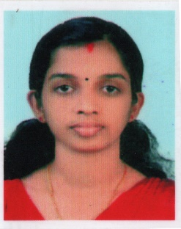

Arya V Nair
Vettoorpurayidam
Thekkethukavala PO
Ponkunnam, Kottayam
Pin 686519
Mob – 9747329355
Email: aryaanooppnkm@gmail.com

Career Objective:
To become professional by which I may put my expertise best for the satisfaction and development of the organization and thereby improving my knowledge and skills for higher tasks.

Academic Chronicle:

Course | Institution | University | Result
B.Ed. Chemistry | ST Thomas College | M G university | 87%
MSc Chemistry | ST. Dominic’s College | M G university | 72%
BSc Chemistry | SVR NSS College | M G university | 88%
HSE | Govt. HSS | Board of Higher Secondary | 80%
S S L C | SVR NSS HS | Board of Public Examination | 75%

Additional Qualification: SET in Chemistry

Experience:

10 Years (2012-onwards) of PGT experience in CBSE School as Higher Secondary School Teacher

Personal Information:
Date of Birth | : | 13-08-1988
Gender | : | Female
Languages Known | : | Malayalam, English
Hobbies | : | Listening Music, Cooking

Declaration:
I hereby declare that the information furnished above is true to the best of my knowledge. I assure my service to your organization may be made remarkable by best use of my knowledge and caliber.

Date: 22-04-2023 Arya V Nair

