AKSA S VICTOR
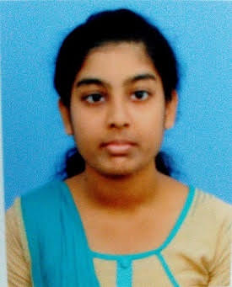

PEACE LAND,
NEAR C.S.I CHURCH
MEPPUKKADA,
MALAYINKEEZH P O,
THIRUVANANTHAPURAM,
KERALA,
INDIA
PIN-695 571

Contact no:
Mob : +91 – 9961059603
+91 - 8891384121
E-MAIL: aksavictor2014@gmail.com

Career Objective
To obtain a responsible and challenging this position, which provides ample opportunity to learn and enrich my competence, where my education will have valuable application, thereby enabling me to grow along with the company.

Strengths
Self-Motivated, Hardworking, Sincere and Dedicated to Work.
Ambitious, Enthusiastic and Creative.
Believer of Team Work.
Focused and calm under pressure-Goal Oriented, Resolve Problems.

Academic Credentials
Course | Specialization | University/College | Year
M.COM | Company Law, Project Finance, Direct Taxes, Advanced Corporate Accounting, Advanced Cost Accounting. | Annamalai University- Distant Education | 2018
B.COM | Co-operation | University of Kerala | 2015
Plus 2 | Commerce | Board Higher Secondary Examination, Kerala  St. Xavier’s Higher Secondary School, Peyad | 2011
S.S.L.C | General | Board of Public Examinations, Kerala  Abraham Memorial Higher Secondary School, Tirumala | 2009

Additional Academic Credentials
- Diploma in Computer Applications – C-DIT - completed with distinction.
- Typewriting English and Computer Word Processing Lower grade completed with second class.
- Typewriting English and Computer Word Processing Higher grade completed with second class.
- Typewriting Malayalam and Computer Word Processing Lower grade completed with second class.
- Diploma in Indian & Foreign Accounting - G-Tech Computer Education – completed with A grade.
- Professional Diploma in Indian and Foreign Accounting and SAP - G-Tech Computer Education – completed with A grade.
- Tally – Sagarmatha Educational & Charitable Society - completed with A grade.

Personal Information

Date of Birth : 17-01-1994
Gender : Female
Marital Status : Married
Languages known : English, Malayalam.
Hobbies : Listening Music, Travelling
Postal Address : Arun Nivas, Panamkalavila, Karali, Parassala P O,
Thiruvananthapuram, Kerala –695 502

I do hereby declare that the above information furnished by me is correct to the best of my knowledge and belief.

Place: Parassala AKSA S VICTOR
Date: 11/03/2022

