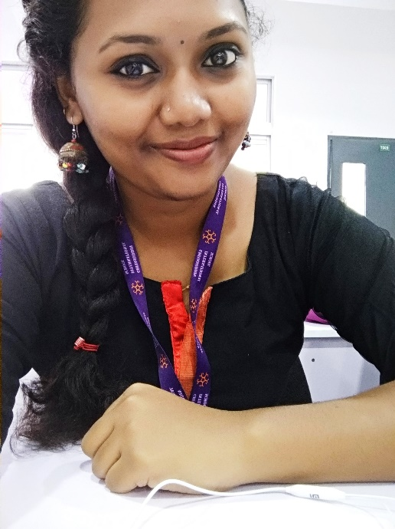
CURRICULUM VITAE
ANJU SURESH
KOYIPURATHU VISAKH
MALAKUNNAM P.O CHANGANACHERRY KOTTAYAM
E-mail: novemberanju@gmail.com
Phone: +918891461645

OBJECTIVE
To pursue a career as a teacher in the field of schools, that will utilise my knowledge and experience in the field of education which in turn will lead to a bright future.
PERSONAL DETAILS
Name : ANJU SURESH
Date of Birth : 04/11/1994
Age : 27
Address : Koyipurathu Visakh, Malakunnam P.O, changanacherry
Father’s Name : K M Suresh Babu
Mother’s Name : Kavitha Suresh
Marital Status : Married
Husband’s Name : Vishnu Viswanath
Religion : Hindu ( Nair)
Nationality : Indian
Hobbies : Listening to music, reading….
Extra Curricular
Activities : Singing , Dancing and Acting

ACADEMIC QUALIFICATIONS
University/ Board | College/ School | Examination | Marks/GPA/ Grade
Mahatma Gandhi University  B.Ed  K-TET | NSS Training College | Semester 1  Semester 2  Semester 3  Semester 4 | 9.73  9.73  9.93  10  Qualified
University of Mysore  MSc. Applied Geology | University of Mysore | Semester 1  Semester 2  Semester 3  Semester 4 | 8.5  8.42  8.35  8.15
Mahatma Gandhi University  BSc Chemistry | NSS Hindu College | Semester 1  Semester 2  Semester 3  Semester 4  Semester 5  Semester 6 | A  A +  A  A+  A+  A+
Kerala State Board | Ithithanam HSS | XII SCERT exam | 95%
CBSE | Placid Vidya Vihar | X CBSE exam | 9.2

EXPIRIENCE
- Working As STEAM Facilitator in Don Bosco School Puthupally
- Worked as a Teacher in Ghiyasuddin International School, MALDIVES (IGSCE Syllabus)
- Worked as a Teacher in Elamkavu vidya mandir, INDIA (CBSE Syllabus)
- Tution Teaching in all Science Subjects for high school and middle school students for 7 years

RESPONSIBILITIES AND ACCOLADES
- School Topper in Kerala State Higher secondary exam 2013.
- University of Mysore first rank holder...
- Under graduate Degree Third Rank at NSS Hindu College with A+ .
- Served as the house captain in Placid vidya vihar , 2009.
- Received Higher Education Scholarship From Kerala Government for Three Years
- Received Post Graduate Indira Gandhi Scholarship For PG level.
- Served as “ Kalathilakam “ of Balajanasakhyam , Kottayam District

VOLUNTEERING ACTIVITIES

- Volunteer Secretary of NSS( National Service Scheme , 2015-16)
- Member for Blood Bank Group, Changanacherry
- Vice Captain of School youth festival , 2009-10

DECLARATION

I Affirm That All The Information Provided Above Are True To My Knowledge And Belief.
ANJU SURESH

