BIBINKUMAR C

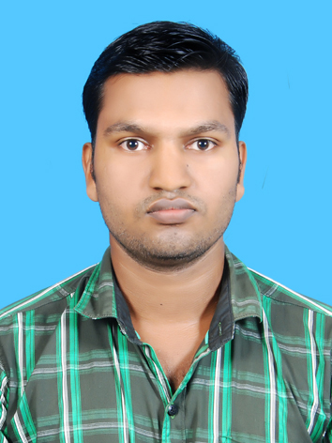

Contact No:
+91-8086248383

Mobile: +91-7306381173

Email: bibinkumarcr7@gmail.com

Present Address:

Pottayil Puthen Veedu, Kizhakke Pannimala, Koothali Post, Trivandrum- 695505

Permanent Address:

Pottayil Puthen Veedu, Kizhakke Pannimala, Koothali Post, Trivandrum- 695505

PROFESSIONAL SUMMARY

Finance Executive with 3+yers of experience in Accounts receivable, Accounts Payable, Handling petty cash, General Ledger accounting, Commercials and Taxation, Financial Accounting Service, Seeking a promising position that offers both a challenge and a good opportunity for growth and to upgrade skills to serve the company better.
PROFESSIONAL EXPERIENCE

Audit and Finance Executive - Centre for Finance & Taxation Management, Trivandrum (CA Firm) (2020 – Present)
- Preparing financial Statements such as Profit & Loss A/C Trial Balance, Balance Sheet, Cash Flow and Funds statements, managing complete accounting cycle including opening posting entries and closing of accounts and preparation of various accounting reports.
- Assisted clients for the impending introduction of Goods & Services Tax (GST) Advising on various issues related Goods & Service Tax (GST), Handling GST assignment to help client in smooth transition from erstwhile tax regime.
- Accounting, Auditing, Taxation
- Internal Auditing
- Preparing Profit and Loss A/c BS.
Statutory Calculations and Filings
- Monthly GSTR Filing
- Monthly EPF AND ESI Filing
- Monthly TDS E-Payment and Quarterly Filing
- ITR Preparation and Filing

Executive – Operations in Aegis Ltd, Techno park Campus, Trivandrum (1 year 7 months)

TECHNICAL SUMMARY

- Tally.ERP 9, Tally Prime
- MS Office Suite
- Internet & E-mail applications

ACADEMIC CREDENTIALS

Course |  | University | Year of Passing | Percentage
MCOM  (General) |  | Annamalai University | 2019 | 61.40
BCOM  (Co-operation) |  | University of Kerala | 2015 | 44.87
PLUS TWO (Science) |  | Kerala Board of Higher Secondary Examination | 2011 | 57.33
SSLC |  | Kerala Board of SSLC Examination | 2009 | 67.00

Personal Information:

DOB : 24/10/1993
Gender : Male
Nationality : Indian
Marital Status: Single

Language Proficiency:

English
Malayalam

DECLARATION

I hereby declare that the details furnished above are true to the best of my knowledge and belief.

BIBINKUMAR C

