RESUME

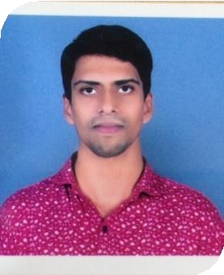ARUN VISHNU RS
Email:-arunvishnurs@gmail.com
Phone No:-8089927644

Career Objective
To make a bright and evocative contribution in my field of quest, create a conductive environment of team spirit to work with total commitment and sincerity to pursue a career in the Computer/Accounts sector. I believe that working in your esteemed organisation would provide me ample opportunity for my career.

Educational Qualification

Course | YearofPassing | Institution/College Studied | Stream | University/Board | Percentage of Marks
B.Com | 2013 | Tandem,TVPM | Commerce | Kerala University | 45
Plus Two | 2009 | St,Mary’s H.S.S, Pattom, TVPM | Humanities | Board of Higher  Secondary Education | 76
SSLC | 2007 | St,Mary’s H.S.S,  Pattom, TVPM | SSLC | Kerala Board | 66
Enrolled as Goods & Service Tax Practitioner Enrollment Number:- 321800000099GPQ

Work Experience
Company:- Kerala Housing Finance Limited, Head Office,Trivandrum
Designation:- Accounts Assistant
Period :- 01st March 2016 to 31st March 2018

Job description

- Collecting daily balances from branches and verifying the cash and bank balances and reporting it to the General Manager.
- Bank Reconciliation.
- Reporting loan defaulters to CIBIL.
- Helping senior officials for preparation of letters etc.
- Loan Recovery.

Company - Mahindra Holidays & Resorts India Limited, Munnar
Designation - Service Associate (Stores/Purchasing Assistant)
Period - 11th February 2019 to 11th July 2019.

Job description

- Assisting Purchasing Manager for purchasing various goods/materials (perishable & non-perishable) required for the Resort on timely basis.
- Inventory Management.

Computer Skills
- Diploma in ComputerHardware
- Tally ERP9.0
- MS Office
- Typing (English) speed @35-40 words per minute
- Adobe PageMaker7.0
- Basics in HTML

Attributes/Abilities
- Good communication
- Self motivated, quick learner
- Positive attitude, hardworking
Personal Profile
Age : 28
Date of Birth : 04-07-1991 Gender : Male MaritalStatus : Single Nationality : Indian
Languages Known : English, Malayalam, Hindi
Address : TC41/386,ThekkeeVeedu, Kuriyathi, Manacaud.P.O
Thiruvananthapuram-695009
Declaration
I do hereby declare that the details furnished above are true to the best of my knowledge, information and belief.

ARUN VISHNU RS
Thiruvananthapuram

