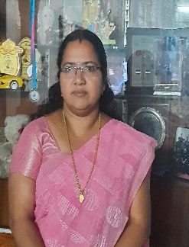
Resume
Name. : Chithra V S
Gender : Female
DOB : 10-05-1986
Nationality : Indian
Religion/ Caste : Hindu / Nair
Name of Guardian : Sreekumar R ( Husband)
Edu. Qualifications: BA , B- Ed (English)
Languages known : Malayalam, English, Hindi, Tamil
Address : Vaikundam, Granoorkuzhi, Puliyoorsalai, Cheruvalloor (PO)
Mob. No. : 7558028520 , 97461 87883
E -Mail. : chithrasreekuttan@gmail.com
Experience : 2 years (Army school ,Pangode)
Education Qualifications
SSLC - 2001
Plus two - 2003
BA ( English) - 2016
B -Ed( English) - 2019
Other Qualifications
- K-TET (Category 2)
- K-TET (Category 3)
- C-TET
- MS OFFICE
- Certificate in Basic Computing
Declaration
I hereby declare that the above mentioned details are true and correct to the best of my knowledge and beliefs. If any case, any information found to be false or incorrect my candidature liable to be reject without any information.
Yours faithfully
Chithra V S
20 Nov. 2023
Vellarada

