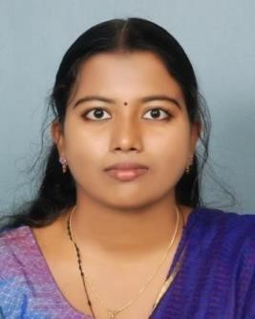
VEENA YESUDAS
KARUNA,
ISRO JUNCTION
CHULLIMANOOR PO
NEDUMANGAD, TRIVANDRUM-695541
Ph: 9497784102, 8590297849
E-mail:veenayesudas06@gmail.com

CAREER OBJECTIVE
Looking forward to working with a leading healthcare organization and achieve a challenging and rewarding career wherein my skills, abilities and knowledge would be a great value and offer professional growth.

PERSONAL DETAILS
Date of Birth : 06/01/1992
Marital status : Single
Mother Tongue : Malayalam
Languages known : Malayalam, English and Hindi
Address : Karuna, ISRO Junction, Chullimanoor PO
Nedumangadu, Trivandrum
Phone : 9497784102, 8590297849

ACADEMIC PROFILE

COURSE | NAME OF THE INSTITUTION | BOARD/  UNIVERSITY | YEAR OF PASS | % OF MARKS
M.Sc  Biochemistry | MALANKARA  CATHOLIC  COLLEGE,  KALIYIKKAVILAI | MANONMANIUM  SUNDARANAR  UNIVERSITY | 2021 | 91.7%
B.Ed | MAR  THEOPHILUS  COLLEGE,  TRIVANDRUM | KERALA  UNIVERSITY | 2016 | 75%
B.Sc CHEMISTRY | MAR IVANIOS  COLLEGE,  TRIVANDRUM | KERALA  UNIVERSITY | 2012 | 72.4%
PLUS TWO  (BIOLOGICAL SCIENCE) | GGHSS  NEDUMANGADU | STATE BOARD | 2009 | 73.33%
SSLC | GGHSS  NEDUMANGAD | STATE BOARD | 2007 | 84%
DCA( DIPLOMA  IN COMPUTER  APPLICATIONS) | NEDUMANGADU | C-DIT | 2013 | 79%

- Preparing for JRF LIFE SCIENCES(CSIR-NET)
- CTET
- Worked as a teacher in St.Marys’ school,Bhadravati in Karnataka for 3 years.
- IELTS

PERSONAL QUALITIES
- Hardworking
- Sincere and punctual
- Positive attitude
- Interactive skills
- Confident

EXTRA CURRICULAR ACTIVITIES
- Active participation in National Service Scheme (NSS) for two years
- Participation in various quiz competitions from school to university levels
- Represented school for Kalolsavava
- Participation in school and college Arts Fest
- Participation in school and college sports

ACHIEVEMENTS
- Won prizes in school and college level arts and sports competitions
- Participated in various seminars on environment and life science related topics

DECLARATION

I hereby declare that the above information true to best of my knowledge and belief.

Place: 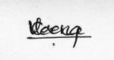
Date: Veena Yesudas

