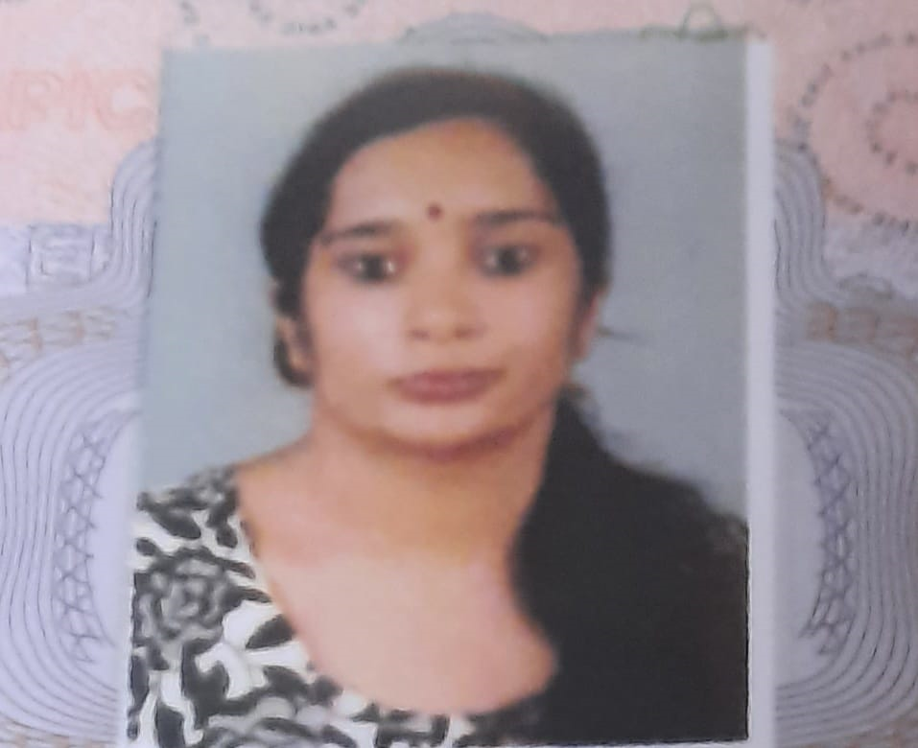

Nivedita Chandrasekharan
Permanent address
Swayamprakash, Opp; SP WELL FORT Hospital, Sasthamangalam, Thiruvananthapuram, Kerala State, India, 695010
Mobile – 6282210178
Email- niveditachandu@gmail.com
-------------------------------------------------------------------------------------------------------------------------
Dear Sir/Madam,
- I am a Post graduate in History from Govt Women's College Thiruvananthapuram…
- Completed and passed BEd from KUCTE, ( Kerala University College Of Teacher Education) Kariyavattom. .

- I am familiar with computer software like MS office, excel, word etc
- I am proficient in English and Hindi languages,
At present I am on the lookout for employment. A detailed bio-data is given below. I believe I have the requirements you are searching for. Looking forward to a long and fruitful relationship with your institution
Yours faithfully,

Nivedita Chandrasekharan

EDUCATION
Date of birth | 4.5.1996
Educational Qualifications: | 2023: B. ed KUCTE) With 82. % Final grade as A .Kariyavattom Thriuvanathapuram.  2020: MA History Govt Women's College Thiruvananthapuram.  Second Class  2017: BA from University of Mumbai with 77% in History with Final A Grade, (from KJ Somaiya College of Arts & Commerce, Mumbai).  2014 :class 12 from Saraswathi Vidyalaya Thiruvananthapuram , passed CBSE with 85%  .  2012:class 10th from NH Goel World School, Raipur, Chhattisgarh,  passed CBSE with 84%  .
Extra Curricular Activities &Hobbies: | Have participated in quizzes and other activities. Hobbies include reading, listening to music. Hindi recitation at college level etc.
Strengths: | Diligent, hardworking and eager to learn, Team Work, Creativity, Attention to detail , Willling to learn , Patience.

