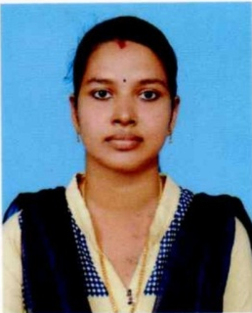  WORK EXPERIENCE  2.5 Years  AGE  29 | JIJI V S  +91 9442028815  jijinandhini@gmail.com  CARRIER OBJECTIVE:  I am particularly interested in finding a position that could offer me the possibility to prove all my achievements.
EDUCATION
M.E. In Structural Engineering  The Rajaas Engineering College, Vadakankulam  Anna University,  Chennai |  |  | Graduated, May 2016  First Class  7.31 CGPA
B.E. In Civil Engineering  Arunachala College Of Engineering For Women,  Vellichanthai  Anna University,  Chennai |  |  | Graduated, April 2013  First Class  7.91 CGPA
HSC  St. Joseph’s HSS, Thirithuvapuram  State Board of Tamil Nadu |  |  | Passed, March 2009  75%
SSLC  St. Joseph’s HSS, Thirithuvapuram  State Board of Tamil Nadu |  |  | Passed, March 2007  84%
WORK EXPERIENCE
ASSISTANT PROFESSOR
November 2016 to April 2019
Marthandam College Of Engineering And Technology, Kuttakuzhi,
Kanyakumari District, Tamil Nadu

Key Responsibilities:
- Worked in Admission cell Department
- Coordinated cultural activities
- Act as a member of ISO files incharge team
- Maintain student database
- Monitoring student progress in subject
CAREER HIGHLIGHTS
- In the Year 2016–2017, One of my students scored full mark (S Grade)
- In the Year 2017–2018, One of my students scored full mark (S Grade)

SKILLS
- Respect |  | - Listening |  | - Verbal&Non–Verbal
- Empathy |  | - Clarity |  | - Communication
- Confidence |  | - Friendliness |  | - ConstructiveFeedback
COMPUTER PROFICIENCY
- MS Office
- Auto CAD

PROJECT DETAILS
- Planning and Designing of A Multi-Storeyed Apartment
- Solution for High Seismic Performance in Prefabricated Building
- Experimental Investigation on Partial Replacement of Fine Aggregate by M-Sand with Superplasticiser.
PERSONAL DETAILS
Father’s Name : Mr.R. Vijayan
Date of Birth : December 23, 1991
Gender : Female
Marital Status : Married
Nationality : Indian
Languages known : Tamil, English, Malayalam
Address : Jiji Cottage, Payas Nagar, Cheruvarakonam.P.O, Parassala,
Thiruvananthapuram Dist, Kerala

Declaration
I, Jiji, here by declare that the information contained herein is true and correct to the best of my knowledge and belief.

Cheruvarakonam, Parassala Jiji V S

