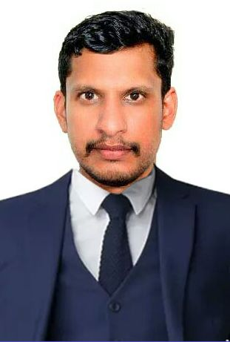

**VIMAL MITHRA S.S**

**( Senior Financial analyst )**

**)**

**OBJECTIVES**

An Ambitious and self motivated individual with an experienced professional having excellent knowledge of financial modelling, reporting and ultimate work knowledge of Tally and SAP basics who is seeking a position in field of Finance &Accounts, Finance analyst or another post that matches to the profile which is for expand and developing the career in your organization and to be a part of use my knowledge, ideas for the future achievement of the successful company.

**CONTACT ME**

**EDUCATION QUALIFICATION**

🎓**MBA FINANCE** with **HR MANAGEMENT**

**-**Maria College of Engineering and technology ,Tamilnadu-(2010_12)

-Anna University (Percentage-70%)

🎓 **B. COM** with **COMPUTER APPLICATION**

-Emmanuel College of Arts and Science, Trivandrum, Kerala -(2008-10)

-Kerala University (Percentage -57%)

**EXPERIENCE**

💼**Currently working at Derik TATA Motors Pvt Ltd, Neeramankara, Trivandrum as Senior Accountant**

💼**4 years** work experience as  **Senior Accountant ( Financeanalyst)**at **Royal Enfield /Marikar Motors Ltd, Trivandrum, Kerala (**2019-22**).**

💼 **5 years** work experience at **Bhima Jewellery** as an **Billing /HR Executive**(2013-2019).

**💼 1year** work experience at **Nilgiris** as an **Accountant** (2012-2013).

**PROJECTS**

-**Kera Fed Ltd** ,Trivandrum(Co-operative federation of Coconut farmers in the southern Indian states of Kerala)

-**Financial Assessment** (2012) (**Project Coordinator** ){Completed

**DECLARATION**

I hereby declare that the information furnished above is true to the best of my knowledge.

**VIMAL MITHRA S.S**

V

**Mithra Nivas, Kovilloor,**

**Ambalam, Manali. P. O,**

**Vellarada, Trivandrum**

**Pin-695505, Kerala,**

**NATIONALITY :INDIAN**

**vimalmithrass@gmail.com**



**LANGUAGE**

* ENGLISH,MALAYALAM,
* HINDI, TAMIL.

**ACHIEVEMENTS**

* NSS, NCC Certificates
* **Tally** ,DTP Certificates

*(****HAVE PASSPORT)***

**SKILLS**

* **TALLY Proficient**
* **Cash flow &Financial data management**
* **MS office Excel, Word, PPT proficient**
* **GST Knowledge**
* **Language Communication Skill**
* **Creativity& Professional**
* **English typewriting skill**
* **Insurance Basics, SAP**
* **Quick learner**

**DOB :**28-01-1990

**GENDER :**MALE

**STATUS :**MARRIED

+91 **9995252344**,7907529970