LAVI KUMARI U-54, Second floor
West Patel Nagar
New Delhi-110008
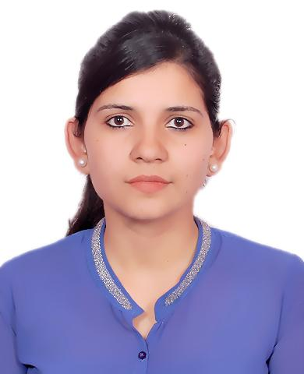 E-Mail id – lavibalyan@gmail.com Contact number : +91 9911311341

Career Objective
Seeking the position of a Teacher in an organization that will enhance my horizon of knowledge and that will boost me to utilize my skill set for the development of an organization.

Core Competencies

- Good communication and written skills as well as ability to explain the text.
- Capacity to arrange the competitions and assess the performance of the students.
- Ability to create an effective teaching method for the children.
- Skilled in using the various tools to make the teaching interesting and effective i.e. books, music and games.
- Ability to identify, concretize, symbolize and use mathematical relationships in everyday life.
- Capable to develop a positive attitude in students towards learning Mathematics.
- Class room management and discipline.
- Proficiency in computer handling and web browsing

Professional Experience
- MSc Mathematics from Jaipur National University
- B.Ed. from GGS Indraprastha University (2013-2014).
- BSC (Mathematics) HONOURS from I.P College of Women (Delhi University) in 2013

Academics
EXAMINATION | SCHOOL /  COLLEGE | BOARD /  UNIVERSITY | SUBJECTS | PERCENTAGE | YEAR OF PASSING
10th | Army Public School | CBSE | English , Hindi, Mathematics, Science , Social Studies | 87.8% | 2007
12th | Army Public School | CBSE | English , Mathematics , Physics , Chemistry , Physical Education | 83% | 2009
B Sc (Hons)  Math | I.P College for women | Delhi University | Mathematics | 52% | 2013
B.Ed | Ideal institute of mgmt. & Tech. | GGSIPU | Maths and Science | 71% | 2014
MSc Math | KCRI College | Jaipur National University | Mathematics | 59.1% | 2020

Teaching Experience
- Pathways School, Gurugram
- MYP Mathematics (IB curriculum) Facilitator from Jan 2019 till Jan 2021.
Job description:
- Delivering scheduled lectures to the assigned MYP classes.
- Creating authentic assessments, skill-based tasks and unit plans.
- Assisting school in grade level events like Awards functions
- Arranging periodic performance evaluation tests and providing detailed feedbacks about areas of improvement

- Amity International School, Sec- 1, Vasundhara, UP
          - TGT Maths (CBSE) from March 2016 till Jan 2019.
Job description:
- Delivering scheduled lectures to the assigned classes.
- Conduct Mental Math Quizzes and prepare students for various Competitions.
- Arranging periodic performance evaluation tests and providing detailed feedbacks about areas of improvement
- Assisting the school administration in arranging special functions / celebrations

- St. Andrews Scots sr. sec. school, I.P Extn., New Delhi
          - TGT Maths from Dec 2014 till February 2016.
Job description:
- Conduct class from standard 5th to 8th.
- Delivering scheduled lectures to the assigned classes.
- Assisting the school administration in arranging special functions / celebrations
- Arranging periodic performance evaluation tests and providing detailed feedbacks about areas of improvement

- Hopes school for special children.
          - 20 hours of teaching experience where we educate children, provide healthcare and train young people and women in skills for livelihoods.

Areas of Interest:
- Giving the best performance for the betterment of the organization
- Using the skill and qualities to achieve the goals of the organization.
- Motivating students to overcome their hesitation and develop better understanding of the concepts.

Personal Profile
Father’s Name - Mr. Pramod Kumar
Mother’s Name - Mrs. Sudesh Devi
Date of Birth - 29 JULY 1992
Marital Status - Married
Nationality - Indian
Religion - Hindu
Gender - Female
Declaration
I, hereby, declare that all the information furnished above is true to the best of my knowledge.
Date: Place:

