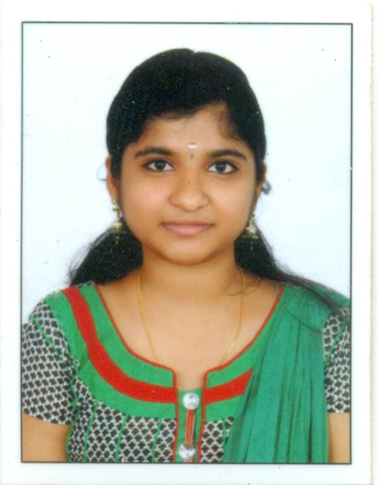
ANJANA. A

Communication
Address: MADATHUVILA
KRISHNA VILASOM BUMGLOW
NADOORKOLLA, AMARAVILA. PO
THIRUVANANTHAPURAM
Kerala, Pin: 695122
Email ID : anjanaabhinash053@gmail.com
Phone No : 9207510795

CAREER OBJECTIVE

To be associated with a progressive organization that gives me the scope to apply my knowledge and skills and involve myself as a part of the team that dynamically works towards the growth of both the organization and myself.

PROFILE SNAPSHOT

- A qualified Diploma in Computer Science with knowledge about software project coordination and presentation.
- An ambitious and confident individual, with drive to achieve and excel on given targets.
EDUCATION DETAILS

- Degree BA English literature – at annamali university with 68% marks in the year 2018
- Diploma (CSE) from GOVT. Polytechnic college, Neyyattinkara with 85% mark in the year 2015
- 12 ^{th} from V. H. S. S Vellanad, Trivandrum, Kerala Board with 79% marks in the year 2012.
- 10 ^{th} from V. H. S. S Vellanad, Trivandrum, Kerala Board with 82% marks in the year 2010.

ACADEMIC PROJECT

- Project name was “INSTITUTION MANAGEMENT SYSTEM”.
- This project solves our problems as to take very easy to manage students, facult, librarianand the accountant at the same time.
- Project handled on “front end : PHP, back end : MySql”.
TECHNICAL SKILLS

- Programming Languages : VB.NET, ASP.NET PHP, Java, VC 6.0, C, C++
- Operating System : Windows 7, Windows 98, 2000, XP, 2010 and Linux
- MS Office : Word, Excel, Power point
- DBMS Packages : MS Access, SQL

TRAINING PROGRAMMES

- Attended Industrial Training Program in Win Wrench software solutions, Techno Park

STRENGTH

- Self Confidence
- Positive approach
- Performing Well under Pressure
- Adaptable to changes
- Ability to learn new Technologies
- Quick Learner and Hard Worker

PROFESSIONAL WORK EXPERIENCE

- From 3rd December-2015 (up to 2nd december 2016)
Designation : Apprentice Trainee
Division : Quality Division Avionics System (QDAS) Vikram Sarabhai Space Centre, Thiruvananthapuram
ISRO, Dept of space
Description of work done:
- Monitoring of various programs and to make adequate changes to enhance its smooth and efficient run.
- Conducting tests and trial runs to ensure that, the program produces the desired results in a timely manner.
- Documentation of the program with the instructions used, for the ease of comprehended coding.
- Participated in various QA activities of “Quality Division Avionics System “(QDAS) division in Vikram Sarabhai Space Centre.
- Maintenance of “Info cache database” (central level database of failure and non-conformance using in ISRO) of different avionics packages allocated for different flights.
- Converting and analyzing of PSLV, GSLV, ATV-D02, and RLV-TD flight data and preparing their reports
- From 1st February-2016 (up to 3rd February 2017)
Designation : Programming Language Teacher
Division : BSS Computer centre, Vilapilsala, thiruvananthapuram
Description of work done:
- Worked on C, C++, and Adobe Photoshop etc.

PERSONAL DETAILS

Date of Birth : 02-May-1995
Father’s Name : Janardhanan Nair N
Nationality : Indian
Gender : Female
Marital status : Married
Language known : English, Malayalam, Hindi, Tamil
Hobbies : Dancing, Traveling, Reading, Hearing music

DECLARATION

I do hereby solemnly declare that all the above furnished details are true to the best of my knowledge.

Place : Amaravila Yours faithfully
Date : 06-10-2021 Anjana. A

